# **Detailed Report on the openCHA Framework**

## **Introduction to CHAs**

### **Conversational Health Agents (CHAs):**

CHAs are sophisticated AI-driven tools designed to facilitate healthcare communication and decision-making. Leveraging advanced natural language processing (NLP) capabilities, they can understand, process, and respond to human language in a healthcare context, providing assistance, information, and guidance to users.

### **Significance of Large Language Models (LLMs) in Healthcare:**

LLMs like GPT-4 enhance CHAs by enabling more accurate and contextually relevant interactions. They help interpret complex medical queries, provide evidence-based responses, and improve patient engagement by delivering personalized healthcare information.

## **Framework Components**

### **Interface:**

The interface serves as the primary interaction point between users and the CHA. Utilising tools like Gradio, it offers a user-friendly platform for patients to input queries and receive responses. The interface ensures accessibility and usability, catering to various user needs.

### **Orchestrator:**

The orchestrator is the brain of the CHA framework, responsible for problem-solving and decision-making. It manages the flow of information, interprets user inputs, and coordinates responses by integrating data from various external sources. The orchestrator ensures that the responses are relevant, accurate, and contextually appropriate.

### **External Sources:**

CHAs integrate with a variety of external sources to provide comprehensive healthcare information. These sources include medical databases, electronic health records (EHRs), clinical guidelines, and real-time health monitoring systems. The integration ensures that the CHAs deliver up-to-date and evidence-based information.

## **Application Scenarios**

### **Personal Healthcare:**

Symptom Checker: CHAs can evaluate symptoms entered by users and provide preliminary diagnoses or recommendations for further action.

Medication Management: They assist users in managing their medications by offering reminders, information on drug interactions, and adherence support.

Chronic Disease Management: CHAs provide tailored advice and support for managing chronic conditions like diabetes, hypertension, and asthma.

Benefits and Challenges:

### **Benefits:**

Improved patient engagement, enhanced access to healthcare information, personalized care, and reduced healthcare costs.

Challenges: Data privacy concerns, the need for accurate and reliable information, potential biases in AI algorithms, and the requirement for continuous updates and monitoring.

Technical Implementation

Gradio Interface:

Gradio provides an intuitive interface that allows users to interact with CHAs easily. It supports various input and output modalities, making the user experience seamless and efficient. Gradio's flexibility and ease of integration make it an ideal choice for the CHA framework.

### **Orchestrator and External APIs:**

The orchestrator communicates with external APIs to fetch necessary data and enhance the CHA's responses. APIs from medical databases, EHR systems, and real-time health monitoring devices are integrated to ensure that the information provided is current and comprehensive. This interaction involves complex data processing and real-time decision-making.

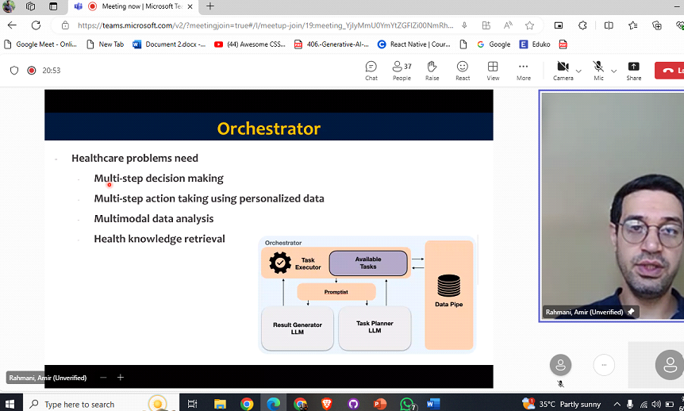

## **Evaluation**

### **Impact on Patient Care:**

The CHA framework has the potential to revolutionise patient care by providing timely, accurate, and personalised healthcare information. It can improve patient outcomes by facilitating early diagnosis, promoting adherence to treatment plans, and enhancing overall patient engagement.

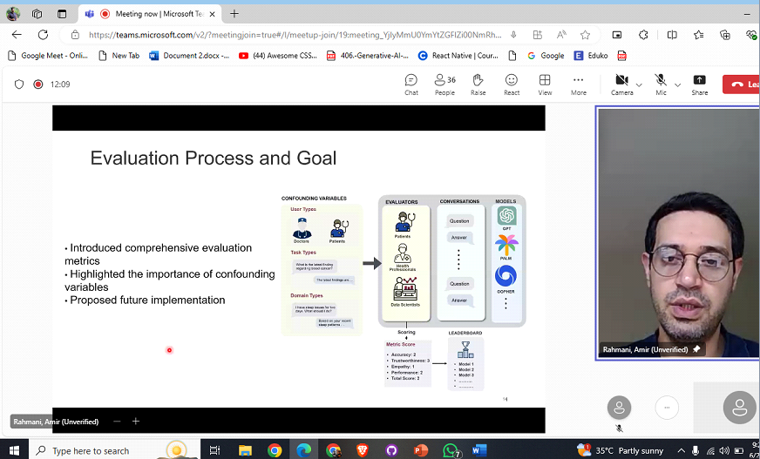

### 

### **Suggestions for Improvement:**

Enhanced Data Security: Implement robust encryption and privacy measures to protect sensitive patient data.

Bias Mitigation: Continuously monitor and update AI algorithms to minimize biases and ensure fairness.

Integration with Wearable Devices: Expand the framework to include data from wearable health devices for real-time monitoring and personalized insights.

User Feedback Mechanism: Incorporate a feedback system to gather user inputs and continuously improve the CHA's performance.